Sorted Height Field Rendering

Mark Finch and Lars Bishop
Numerical Design Limited

Abstract
We present a straightforward and efficient algorithm for the real-time rendering of height field data in sorted order employing continuous LOD. The method presented generates a spatially and temporally continuous skin of antialiased texture mapped triangles without the overhead of tree structures or off-line computing of supplemental data. The triangles forming the skin are generated in sorted order at a constant rate throughout the frame in time linear to the number of triangles generated.

1. Introduction
The optimum tessellation of a height field is dependent on both the intent of the application and the data set. In contrast with existing surface reconstruction and visualization algorithms for which the rendered surface is the focus, the work presented here targets applications rendering a height field, typically terrain, as a setting or environment in which the user moves unconstrained at ground level or low altitude. This environment is expected to be detailed and varying, populated with dynamic models, and enhanced by shading, fog, and other dramatic visual effects. The requirements of such applications are discussed in Section 2, while Section 3 outlines selected recent research as relating to these needs and the resulting design decisions.
The full algorithm is detailed in Section 4 in a top down fashion. Care is taken to refer design and implementation details back to the stated system goals. Top level system components, which are not technically part of the tessellation process, are described to the degree on which the rendering depends on them.
Experimental data and analysis is presented in Section 5. Performance figures and trends gathered from a 133MHz Pentium PC with and without hardware acceleration demonstrate the scalability of the system.

2. Design Issues
The terrain rendering system was designed around a clear set of requirements. The system must provide high performance and quality on current low end systems, but take advantage of higher end platforms as well as future advancements. In particular, faster processors, graphics accelerators, and multiprocessing environments should controllably improve speed and/or quality. Texture mapping is assumed indispensable to augment geometric detail. The tessellation of the terrain database cannot be uniform, but rather sampling must be dynamically budgeted based on importance. It is further assumed that sampling the database while maintaining adequate frame rates will not be adequate to bound errors to within a few pixels. Therefore, as terrain moves from coarse tessellation to finer it must be smoothly morphed to avoid the distracting “popping” effect. For load balancing with graphics hardware or in multiprocessor environments, triangles must be steadily produced throughout the frame. These triangles are ideally generated in sorted order, front to back in the presence of Z-buffering, or back to front for the painter’s algorithm. Finally, the system must provide a general and friendly interface to the application layer, providing a high degree of control both in database management and rendering, while hiding the complexity of the underlying system.
The following list summarizes the requirements of the terrain rendering system:
- Importance driven geometric reduction
- Antialiased texture mapping
- Shading
- Smooth morphing
- Vertex Matching (No T-junctions)
- Separable loading (pages)
- Separable rendering (strips)
- Sorted triangle generation
- Broad scalability
- On-the-fly tunability
- Low overhead
- Graceful degradation under stress

There is obvious overlap between some requirements, while others interact in more subtle ways. Their impacts on design decisions are highlighted later as the design is detailed.

3. Prior Work
The use of triangulated irregular networks (TINs) is often discounted in real-time terrain rendering literature. The complexity of TIN generation relegates it to an off-line process[11], and once generated, the TIN model does not lend itself to operations trivial for Regular Square Grids (RSGs). For instance, while excellent work has been done in creation of multiresolution TIN models [5], matching of regions of differing resolution (crack prevention) may offset the gains. It is often neglected that for many typical data sets and application requirements, a TIN may provide such data compression that rendering the full resolution TIN may be more efficient in time and space than is possible using techniques that facilitate view dependent multiple Level Of Detail (LOD) selection. It is therefore not lightly that TINs are deemed inappropriate for the work presented here. While efficient terrain inquiry methods have been developed for TINs[9,10], the expected frequency of such operations for the targeted applications requires such operations to be done not only in constant time, but with a very low time constant. More importantly, the benefits of TINs diminish as they are constrained beyond feature matching. Respecting texture map boundaries eliminates the gains of condensing large flat expanses into a few large triangles. Similarly, limiting screen space triangle size would require on-the-fly triangle reduction or further limiting the retriangulation.
RSGs, while not tessellating a height field as well as TIN approaches[6], operate fast enough to allow view dependent tessellations in real or near-real time. They are primarily distinguished by their vertex selection method (triangles generated are implied by which vertices are selected for a given frame). A simple but effective method is the division of the height field data (which may be considered infinite in horizontal extent) into fixed size “pages”. Each frame, each visible page is tessellated uniformly at some LOD determined by the page’s data and the eyepoint. Adjacent pages of differing resolution are stitched together with fill triangles.[3]
Greater compression for the same quality rendering may be obtained by selection of vertices on an individual basis. Restricted quad tree approaches so select vertices such that tessellating the resulting set of vertices with a continuous matching skin is highly efficient. [5] The nature of vertex selection varies widely in intent and cost. Gross et. al. provide an innovative marriage of minimizing model space error while accounting for importance to the view[7], while Lindstrom et. al. attempt to bound screen space error.[8]

4. Method
4.1 Overview
It is convenient to define the LOD quantity of an RSG in terms of the base 2 logarithm of its sampling interval, such that LOD=0 refers to sampling every value in the base height field, LOD=1 samples every other height, etc. The direct relation of the LOD with the sampling rate is then clear, and throughout this paper the two will be used interchangeably.
Real-time multiresolution height field rendering as implemented by RSG algorithms may be logically broken into two processes. The first is vertex selection for a given frame based on some importance criterion which is generally a weighted function of local geometry and importance to the viewer. The selection process is further constrained such that the output set of vertices may be efficiently converted to a continuous skin of triangles without T-junctions. It is generally sufficient that the LOD never change by more than a small fixed number between two adjacent regions (e.g. 2 in [7] and 1 in [8,12]). The second process gathers the selected vertices, converting them into a form palatable to the rendering engine (e.g. attaches shading and texture map coordinates) and feeds them into the rendering pipeline.
The system presented here collapses both operations into a single pass over the visible portion of the height field. A small bounded amount of computational work per triangle selects vertices, generates triangles preserving spatial and temporal continuity, and feeds them into the graphics pipeline in sorted order. This is made possible by recognizing that, for the target application domain, the need for a uniform screen space triangle size far outweighs the need to bound fidelity to the data.
Uniform sized screen triangles are essential for low end systems relying on software rasterizers, for which perspective correction exacts significant cost. Even on hardware accelerated systems, however, regulating the maximum screen size of triangles enables the effective use of Gouraud shading to provide extremely cheap dramatic effects. For example, the standard technique of applying “fog” to fade triangles into the horizon cannot interpolate between vertex fog values when a single triangle may cover the flat expanse from the viewer to the far clipping plane. In that case, fogging must be applied on a per pixel basis. Local lighting effects for explosions or night scenes rely on adequate density of vertices on the screen to allow the interpolation of illumination values. Alternate methods of overlaying these and other effects onto triangles of unknown extent and depth complexity are expensive in system resources, artistic and engineering work, or both.
As methods which provide dense tessellation in regions of high spatial frequency rely on large triangles in flat regions to offset the cost [2], the prohibition of large triangles by texture map boundaries and screen size limiting precludes their use. Fortunately, the sampling densities achievable here, augmented by texture maps for fine detail, are sufficient to provide compelling realism on a wide range of terrain types and on a wide scale of systems, from low end consumer level PCs up.
It is important to note that any vertex selection method which outputs a set of vertices satisfying the single LOD step between adjacent regions could be used as the front end of the sorted order triangle generation method presented here. If in addition to the Boolean on/off of a vertex, it provides a fractional value in the range [0..1) indicating how on that vertex is, temporal continuity though vertex blending (smooth morphing) will also be established. While the resulting hybrid system would be quite powerful, for the reasons stated above, it would be less appropriate for our targeted application domain.
4.2 Data Organization
The terrain database is broken at the application level into units referred to as pages. All pages of a given data set are square height fields of the same dimensions. Their world space size is also uniform. The height field dimension is a power of two plus one on an edge, the adjacent edges of two pages having the same values. Also associated with each page is a set of texture maps of descending resolution.
In a typical application, an entire terrain data set would severely tax the memory management system if loaded as a unit, severely compromising system performance and causing excessive start up times. The page based system allows the application to keep only the current region of interest in memory, asynchronously prefetching pages before they come into view, and discarding pages that have been passed.[3] The page based system also allows critical optimizations. An entire page may be culled based on its bounding volume. Lighting, fogging and clipping are restricted to those pages which require them. In practice the extent of a terrain texture overlaid onto the terrain height field defines the page size.
There is a clear tradeoff on selection of page size. Larger pages allow a greater reduction in the number of triangles drawn, while smaller pages allow more efficient rendering of those triangles. The rendering engine, particularly in the presence of 3D hardware, may impose a cap on texture size and hence page size.
4.3 Selection Of Footprint
All terrain potentially visible from a viewpoint lies within a polyhedron formed by the intersection of the view frustum with the planes of maximum and minimum height of the database. The footprint of the view on the terrain is the projection of this polyhedron onto the domain of the terrain height field. Since the terrain is considered to be of infinite extent, its bounding region is only finite in the height dimension. No terrain data outside of this footprint could be visible, and need not be loaded into memory [3]. However, any page at least partially inside this footprint is potentially visible. Again, large pages will require loading of large amounts of height and texture data when only a small fraction of the page is visible.
The footprint obtained is a convex planar polygon containing all potentially visible terrain data. The application is notified if any pages within the footprint have not yet been loaded. The footprint is then rastered out to generate the terrain triangles. Currently, the footprint is rastered back to front along the horizontal dimension most perpendicular to the view direction. The capability to raster front to back is a trivial extension. The front-to-back regular grid nature of triangle generation makes it possible to interleave the drawing of objects above the terrain with terrain generation so that the objects correctly obscure (and are obscured by) the terrain[12].
The rastering operation breaks the terrain into strips a single triangle in width. The width of a strip reflects the current sampling rate and strips may be further subdivided as described below.
It is important to note that each strip depends only on the previous strip’s tessellation to prevent cracks. While global solutions may only begin producing triangles at the tail end of processing, this system begins feeding the graphics pipeline immediately. Furthermore, as will be seen the work to generate a triangle remains nearly constant, so triangle generation continues throughout at a steady rate. This is an important consideration in the presence of multiple processors or asynchronous graphics hardware.
4.4 Generation of Terrain Geometry
The strip generation process creates the geometric representation of the terrain by stepping along in the horizontal direction (called the minor direction) that is closest to perpendicular to the view direction, generating sets of triangles that complete quadrilaterals of the given LOD size. The border of each quad contains the current vertex being examined, the next previous strip vertex, and vertices from the front edge of the strip directly behind. The quad may also contain other vertices between these, in order to allow splitting of quads when moving to finer LODs and to ensure that no cracking occurs. This is illustrated in Figure 1.
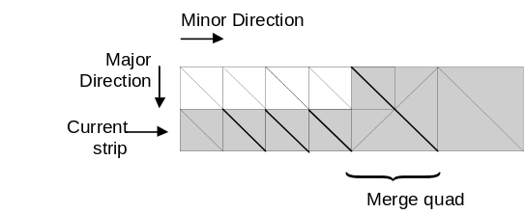
Figure 3 Merging quads to coarser level of detail.
Quads of a given LOD must be aligned to that LOD - for example, a quad at the coarsest LOD is the size of a page, and must be aligned to page boundaries. Thus, every vertex in a page has a coarsest possible LOD value (determined by its alignment in the page). This greatly simplifies the quad generation process and ensures that quads never cross page boundaries. There are a small, finite number of quad configurations; Every LOD uses the same configurations, scaled to that LOD’s quad size.
4.5 Geometric LOD Transitions
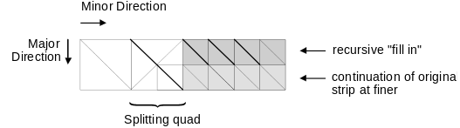
Figure 2 Splitting quads to finer level of detail.
The level of detail selected at a given vertex is a function of that vertex’s position and the relative position of the eye. The exact nature of the function is arbitrary, subject to the constraint that no generated triangle cross two LOD transitions. Currently a log distance to the eye function is implemented to provide constant screen space triangle size as:
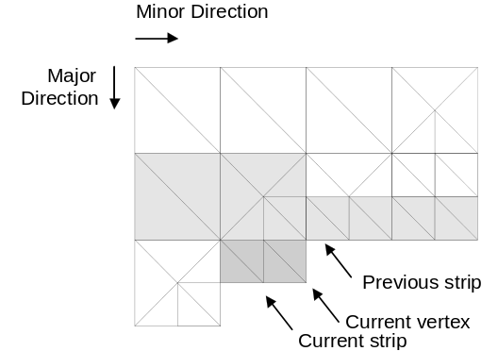
Figure 1 Terrain quads at two levels of detail.
LOD = LUT[ DistToEyeSq(vertex)*LODScaleFactor]
As the function is implemented as a lookup table, other scalar functions of distance may be easily implemented by the application providing an alternate lookup table.
As the stripping process moves along, there are two major transitions that may occur; Splitting to a finer LOD, and merging to a coarser LOD. Note that both of these transitions ensure that the front edge of a strip never moves forward or backward in the major direction from its starting position, even in the presence of merging or splitting.
A split occurs when the stripping process determines that the LOD function evaluated at the current vertex indicates a change to the next finer LOD. It splits by drawing a splitting quad of the current size and then creating a new strip that recursively draws the further of the two strips that will continue on at the finer LOD as shown in Figure 2. Once the rear “fill-in” strip completes, the current strip continues on with the same front edge, but starting with quads half as large as before.
A merge occurs when the process determines that the strip directly behind the current quad is further back than the size of the current LOD, and that the current front edge is aligned to the next higher LOD. This may be determined by examining two vertices. If the criteria are met, the process draws the merging quad in Figure 3 at the size of the new, coarser LOD and continues on with the process, generating quads at the new LOD.
A quad must use the same vertices along its back edge that were used for the front edge of the quad or quads directly behind it, so as not to produce cracks in the terrain. Since we assume that the LOD function will never change more than one level up or down in the space of a quad, there are only three possible configurations of the back edge of the new quad; It must span one vertex (quad behind it is double the size), two vertices (quad behind it is the same size), or three vertices (two quads of half size are behind) that were used for the previous strip. This may be determined by examining at most three vertices. Due to overlap in the method between the various cases, the correct quad configuration can be entirely determined by (at most): examining the current vertex’s alignment with respect to the next higher LOD, examining 2 vertices for usage in the current frame, and evaluation of the LOD function at the current vertex.
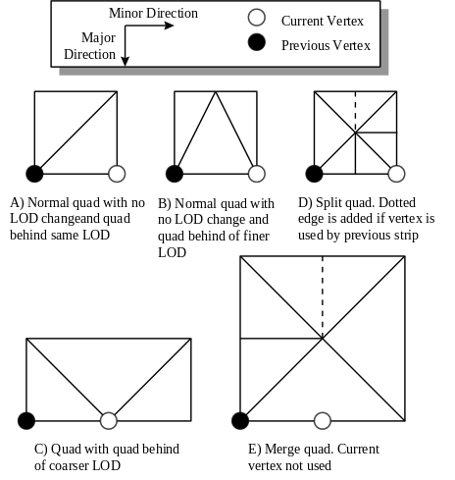
Figure 4 Possible Quadrilateral Constructions
Vertices are allocated only when used for a given frame’s representation, allowing for simple and fast determination of which vertices are and are not part of a given frame. Also, since vertices along the edges of a page represent the same vertices as those along the edges of another page, the stripping process copies edge vertices forward across page boundaries.
Any strip continues adding quads in the minor direction until the next quad would either be part of a page that is not in the visible footprint (the strip has run off the edge of the screen), or until the next quad would cause a shift to a coarser LOD that would cause the current strip to expand forward (the strip was a recursive “fill-in” strip at that LOD). Thus the stopping criteria require only a small, constant amount of work per quad.
The following section details the quad generation process in our current implementation. It should also be noted that the quad creation process is repeated for each frame. The expense of this process is so low that this repetitive calculation represents an extremely beneficial time/space tradeoff over the entire performance spectrum of target machines.
4.6 Pseudocode for Quad Generation Process.
This section describes in detail the method used at each vertex in the stripping process to decide what level of detail is to be used, the triangles to be generated, and the next vertex to be considered. Figure 4 shows all possible quad configurations for a given set of major and minor stripping directions. Assuming that we are in the stripping process at some vertex P, stepping along at a current LOD of L, then the next quad will be generated according to the following method:
(Notation:
P+/-M denotes a step of the current LOD size forward or back from P in the major direction.
P+/-m is the same for the minor direction.
P+2M and P+M/2 denote steps of twice and half the current LOD size
LODFUNC(P) is the LOD function evaluated at P):

GenerateNextQuad() {
SWITCH(P’s alignment with respect to LOD L+1) {
CASE (Aligned in minor direction (major irrelevant))
NormalQuad()
CASE (Aligned in major but not minor direction)
if(vertex at P-M has been used this frame)
NormalQuad()
else // Merging to higher LOD {
Draw quad shown in figure 4 E),
advance,
double step size (L = L + 1) and advance again
}
CASE (Not aligned in either direction)
if(LODFUNC(P) > L) // End of rear fill-in strip
End Strip
else
if(vertex at P-M has been used this frame)
NormalQuad()
else // Matching higher LOD behind
Draw quad shown in figure 4 C) and advance twice
}
}

NormalQuad() {
if(LODFUNC(P) < L) // split to lower LOD {
Draw quad shown in figure 4 D)
Draw recursive fill in strip of LOD L-1 starting
at P+m/2-M/2
Halve step size (L = L - 1) and advance
}
else {
if(vertex at P-M-m/2 has been used this frame) // Regular
Draw quad shown in figure 4 B) and advance
else
Draw quad shown in figure 4 A) and advance
}

4.7 Starting a New Strip
The method described above defines the progression of the method for recursive strips, whose starting positions and LODs are set by the parent strip creating them, as well as for top-level strips already underway. The starting position and LOD of top-level strips are handled differently. For the following discussion, the term “major (minor) direction page” refer to the line of pages that share the same major (minor) direction coordinate. In the current method, a strip always stays within a major direction page.
Top level strips always begin on a page boundary in the minor direction. When a new top-level strip is begun, the front edge of the previous strip (which was constant in the major direction across the entire strip) is checked to see if it fell on a major direction page boundary. If not, then the starting position of the new strip in the minor direction is the same as it was for the last strip. If the last top-level strip had its front edge on a major direction page boundary, then the visible page footprint is checked to find the starting and ending pages in the minor direction for the new major direction page. The new starting minor page boundary is used for the strip.
The major direction position of the new strip is dependent upon the starting LOD of the new strip. The starting LOD of the new strip is found by starting at the vertex that is located at the intersection of the front edge of the previous strip and the new strip’s minor direction starting position. The initial estimate of the starting LOD is set to the starting LOD of the previous strip and position and LOD estimate are adjusted as necessary.
4.8 Texture LOD
Each page has associated with it a sequence of texture maps of decreasing resolution. These are provided by the application. Ideally, to avoid edge effects, the global texture map should be repeatedly filtered and decimated, the downsampled versions then being diced into page units. Filtering after dicing will produce unpleasant effects along all page boundaries. Like the height field data, the adjacent edges of adjacent texture maps should be equal. That is, the last texel on a given row should be equal to the first texel on the same row of the next page. Each triangle generated will be matched with a single texture map of appropriate resolution from the page’s list, providing a strong degree of texture antialiasing with or without hardware support.
While pyramidal mipmapping is a powerful and efficient tool in the display of models, its current implementations make it inappropriate for the display of terrain databases. The texture memory available even on high end graphics systems is insufficient to hold the textures for the entire visible section of the terrain at resolution high enough for the terrain closest to the viewer. Unfortunately, in current systems the entire mipmap must be loaded into texture memory, even if only the top few lowest resolution, and hence lowest memory usage, levels will be used.
For a database containing the range of scale that terrain does, the system must allow the selection of texture map resolution on a per triangle basis. Only those texture resolutions actually selected are loaded into texture memory, allowing large extensions to the yon clipping plane without significant drain of system resources, while maintaining high quality resolution in the vicinity of the camera.
This system also allows the application to quickly load a low resolution texture for a page coming into view, and start an asynchronous load of the higher resolution maps. The low resolution texture will be used until the high resolution load is completed, helping to avoid stalls at start up, as the camera moves, or as data arrives over the network.
4.9 Height Blending
As discussed above, it is assumed that the system will in general be unable to maintain reasonable frame rates if it is required to use a geometric sampling rate high enough to bound representation errors to less than a few pixels in screen space. As a result, severe visual “popping” can result in the terrain representation as the camera moves closer to areas of the terrain that contain high frequency changes in height. This popping occurs when the edge between two adjacent vertices in one frame is broken into two edges by the introduction of a non collinear vertex of a finer LOD in the next frame.
The system alleviates this popping by using an LOD function that includes not only an integer value, but also a fractional part that represents the location of the current vertex with respect to the near and far boundaries of its integer LOD function value. This fractional part is used to smoothly introduce vertices of finer LODs as sections of the terrain come closer to the eyepoint [2]. When the quadrilateral generation method described above determines that a vertex is to be part of the current strip, its height value and those of two of its neighbors of the next coarser LOD are blended using a weighted average.
The averaging of the “new” vertex with these neighbors is weighted by a function of the new vertex’s fractional LOD value. This causes a vertex to be that has just barely crossed into an LOD for which it is valid to lie collinear with respect to its coarser LOD neighbors. As the new vertex continues to move closer to the camera, its fractional LOD value will change smoothly, and the vertex will smoothly rise or fall to its correct height. The two neighboring vertices are selected so that the new vertex is blended with vertices that formed the endpoints of an edge that cross over the new vertex’s position. This causes the new vertex to break an edge into two edges smoothly.
Visually, this blending tends to cause smooth “morphing” of the terrain, without the jarring temporal discontinuities that occur when discrete additions of vertices at their correct height is allowed. The cost of this blending is minimal and pays for itself by allowing LOD transitions to occur at much closer distances to the camera than would be acceptable with discrete vertex addition.
As a new vertex is introduced (or removed) collinearly to prevent geometric popping, in the absence of texture perspective correction, there remains a pop as the perspective distortion grows (diminishes) from the changing tessellation. For a small performance price the blending may be moved from the single height dimension to a 3-dimensional interpolation from one of the edge’s endpoints to the new vertex’s natural position.[1]
4.10 Tuning Parameters

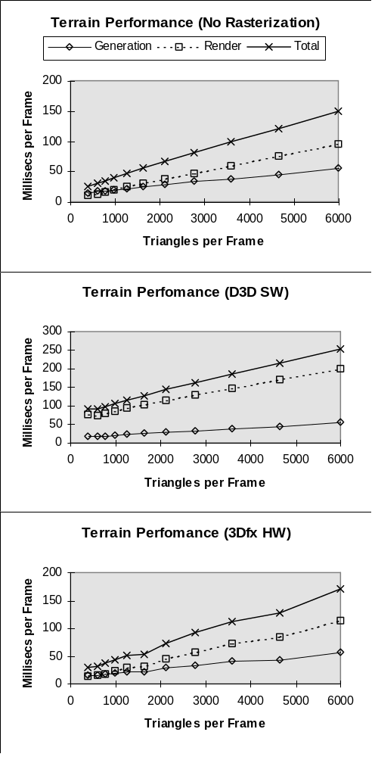
Figure 5 Performance Time vs. Triangle Count
The triangle generation process may be dynamically controlled to maintain constant frame rate through a small set of parameters. It should be first noted that as the camera rises in altitude, maintaining a constant screen space triangle size reduces the number of triangles necessary to cover the visible terrain. On the other hand, as the camera lowers to the terrain, the apparent horizon closes in. Thus the yon clipping plane may be brought in toward the camera at low camera height to compensate for the increasing number of triangles being generated, providing a good degree of constancy in work load. This may be fine tuned by adjusting the distance of the LOD transition boundaries from the eye point through a single scalar value. The LOD scaling value may be set on a frame by frame basis to regulate number of polygons generated, time per frame, or any other metric of the application’s choosing. Note that none of these manipulations alter the overhead of the system. The work required to generate each triangle remains constant.

5. Results
The described terrain algorithm has been implemented in C++ as part of an integrated graphics toolkit. Performance testing was conducted on a 133MHz Pentium-based PC with 32 Megabytes of main RAM.
The tests consisted of “flying” the viewpoint in a circular pattern around the data set, with the camera height constrained to follow the terrain. The path constituted 1000 frames, with camera position dependent only on frame number, not on frame rate. A scene of infinite extent was created by tiling an 8x8 page data set across the entire plane. Each page consisted of 65x65 vertices, giving a maximum resolution of 8192 triangles per page. The view footprint intersected an average of 35 pages in each frame, giving a maximum resolution of 286,720 polygons generated per frame.
Performance results were gathered in three series, differing only by the method used to rasterize the transformed and clipped screen-space triangles. The three rasterization methods were; No rasterization, Microsoft’s Direct 3D immediate ramp-mode software rasterization, and rasterization by a 3Dfx Voodoo Graphics-based hardware rasterizer via Direct 3D immediate RGB-mode. The Direct3D software rasterizers were chosen over custom rasterizers for consistency across all tests. All tests were conducted with a 640x480 pixel framebuffer, with perspective correction and texture mapping turned on in both software and hardware rasterizers.
The LOD function was constant during the course of each individual run, and was adjusted between each successive run to move the LOD crossover points further away from the eyepoint. This created a sequence of average per-frame triangle counts that ranged from approximately 400 to 6000 generated triangles per frame. The generated triangles per frame value represents the number of triangles created by the terrain system, and includes polygons that may be clipped or culled by the renderer.
Figure 5 summarize the results of these tests. The three “Generation” timing values represent the time spent running the method described by the paper to generate model-space triangle sets. The three “Render” timing values represent the time spent in the (software) geometric front-end pipeline, including transforming and clipping and the (software or hardware) rasterization back-end pipeline. Finally, the “Total” timing values show the sum of the corresponding preparation and rendering values.
As can be seen from the figures, terrain preparation time is linear with respect to the number of generated triangles even with a small number of generated triangles, showing that the algorithm scales well over a wide range of resolutions.
Also, the overhead for terrain generation is quite low, as noted by the fact that terrain preparation itself (neglecting all rendering) attained an average of approximately 60 frames per second at 400 output polygons. At this number of generated polygons, the terrain system was generating an average of fewer than 12 polygons per page, attesting to the low per page overhead of the method.
Finally, the cost of terrain generation on a per triangle basis is low compared to the software geometric front-end (note the timing curve for “No Rasterization”), with software geometric computations crossing over terrain generation at around 1000 generated triangles per frame.
Obviously the effectiveness of the tradeoffs employed in this module can only be evaluated within applications. Furthermore, the quality improvement provided by morphing vertex position rather than permitting “popping” is subjective,[4]. However, Figure 6 gives some idea of the level of quality maintained in an application.
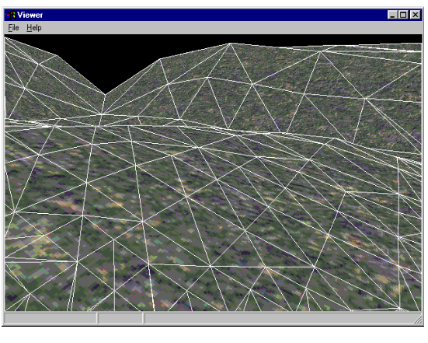
Figure 6 Example image generated by method
The screen shot in Figure 6 shows what the viewer sees in an interactive fly-by application. Note that the terrain module maintains levels of detail for which the screen area of all polygons is relatively constant. Figure 7 is a schematic diagram of the tessellation used to create Figure 6, as viewed from above and behind Figure 6’s viewpoint, with page boundaries marked in dark lines.
Our experience has been that acceptable quality levels for game applications can be readily achieved, even on machines with no 3D acceleration hardware. Using the Direct3D software rasterizers, the terrain renderer provides acceptable visual quality at a 15 Hz frame rate by maintaining a level of detail such that approximately 400 polygons are sent to the graphics on an unaccelerated 133 MHz Pentium processor. Within a game application utilizing custom software rasterizers, the performance can be expected to rise to over 20 Hz with similar geometric complexity. With typical consumer hardware acceleration the level of performance doubles to either a 40 Hz frame rate or twice the geometric complexity at the same frame rate.

6. Concluding Remarks
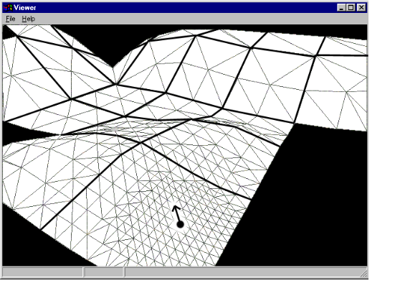
Figure 7 Schematic representation of tesselation used for previous image with page boundaries and eyepoint marked.
Rather than supplanting the existing approaches to height field rendering, we hope to have filled a gap in which such approaches are inappropriate. Whether because of fairly uniform frequency content in the height field data, application needs for uniform eye-space vertex density, or restrictions on tessellation with respect to texture map boundaries, for many applications weighing in local geometry considerations into the tessellation process adds expense without allowing the benefits of those methods. For such applications, we have demonstrated a method with which the results of a restricted quad-tree approach in which the weighting between local geometry and proximity to viewer is zero and one respectively, may be generated in less time and with added benefits of sorting and blending.
By decoupling the vertex selection and triangle generation we also hope to have shown that other methods of vertex selection might also reap these benefits by selecting vertices by their method, possibly dependent on local geometry, followed by a separate pass with our triangle generation to produce the sorted, blended triangles for rendering.

7. Future Work
The current limiting factor in geometry reduction is that no quad may be larger than a page. The only reason for this is that triangles must adhere to texture map boundaries. An even higher geometry reduction rate could be attained by allowing blocks of pages to be represented by one quad by allowing the method to skip vertices at scales larger than a page possibly by using low resolution textures spanning multiple pages (or no texturing at all) for these quads.
Further removal of “popping” and sampling artifacts might be achieved at the cost of increased storage by using a true multiresolution representation of the height fields. Such a representation would ensure that vertices sampled by the terrain generation process at a given sampling rate (i.e. LOD) had been prefiltered by a kernel of appropriate scale.
The terrain method could be used to render “cave” or “tunnel” scenes by drawing two terrain objects in an interleaved fashion, with one terrain object for the floor, and the other for the ceiling. Care would have to be taken in “stitching” the two objects together wherever they met, as well as stopping the drawing of the terrain strips at such points to ensure that the scenes were not overdrawn incorrectly. Other related research could include more generalized “stitching” of multiple terrain datasets, either to create more complex topologies, or to merge terrain objects of different base resolutions.
Finally, the method’s incremental generation of terrain geometry (the generation of individual strips) makes the method ideal for multithreaded implementations.

8. References
[1] COHEN-OR, D., and YISHAY L. Temporal Continuity of Levels of Detail in Delaunay Triangulated Terrain. In Proceedings of Visualization ’96, 1996, pp. 516, 37-42.
[2] COSMAN, M. A., A. E. MATHISEN, and J. A. ROBINSON. A New Visual System to Support Advanced Requirements. In Proceedings, IMAGE V Conference, June 1990, pp. 370-380.
[3] FALBY, J. S., ZYDA, M. J., PRATT, D. R., and MACKEY, R. L. NPSNET: Hierarchical Data Structures for Real-Time Three-Dimensional Visual Simulation. Computers & Graphics, 17(1), 1993, pp. 65-69.
[4] FERGUSON, R. L., ECONOMY, R., KELLY, W. A., and RAMOS, P. P. Continuous Terrain Level of Detail for Visual Simulation. In Proceedings, IMAGE V Conference, June 1990, pp. 144-151.
[5]FLORIANI, L. D., MARZANO, P. and PUPPO, E. Multiresolution Models for Topographic Surface Description. In The Visual Computer 1996, 12 pp. 317-345.
[6] FOWLER, R. J. and LITTLE, J. J. Automatic Extraction of Irregular Network Digital Terrain Models. Proceedings of SIGGRAPH 79. In Computer Graphics 13(2), August 1979, pp. 199-207.
[7] GROSS, M. H., GATTI, R., and STAADT, O. Fast Multiresolution Surface Meshing. In Proceedings of Visualization ’95, October 199, pp. 135-142.
[8] LINDSTROM, P. KOOLER, D., RIBARSKY, W. HODGES, L. F., FAUST, N. and TURNER, G. A. Real-Time, Continuous Level of Detail Rendering of Height Fields. In Proceedings of SIGGRAPH 96. In Computer Graphics August 1996, pp. 109-118.
[9] SCARLATOS, L. L. A Refined Triangulation Hierarchy for Multiple Levels of Terrain Detail. In Proceedings, IMAGEV Conference, June 1990, pp. 114-122.
[10] SCARLATOS, L. and PAVLIDIS, T. Hierarchical Triangulation Using Cartographic Coherence. In Graphical Models and Image Processing 54(2), March 1992, pp. 147-161.
[11] SCHROEDER, W. J. and ROSSBACH, P. Managing the Complexity of Digital Terrain Models. Computers & Graphics 18(6), 1994, pp. 775-783.
[12] ZYDA, M. J., MCGHEE, R. B. MCCONKLE, C. M., NELSON, A. H. and ROSS, R. S. A Real-Time Three-Dimensional Moving Platform Visualization Tool. Computers & Graphics 14(2), 1990.

